Approx Housing Requirements sheets
AppUSBCAR1 APPROX
Description | Approx Model | Picture
Car charger 5V1A 1 USB White | APUSBCARW | 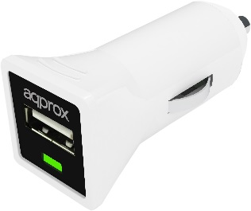
Car charger 5V1A 1 USB Black | APUSBCARB | 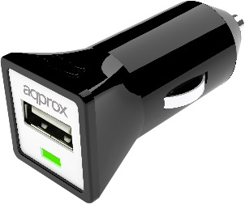
Car charger 5V1A 1 USB Purple | APUSBCARP | 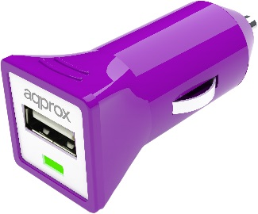
¡¡ATTECION!! THESE PICTURES ARE SAMPLE ONLY, IT ISN´T A COPY EXACTLY OF REALITY… THE COLOURS WILL BE THE INDICATED PANTONE AND DESIGN THE INDICATED IN THE STP. FILE.

BOTTOM
TOP

STICKER

*Sticker:
This part will be as your sample. Look the sample: 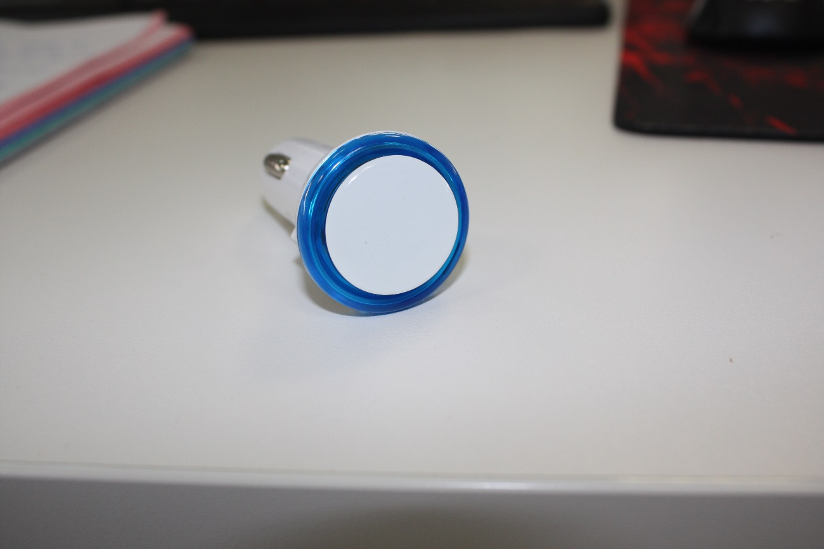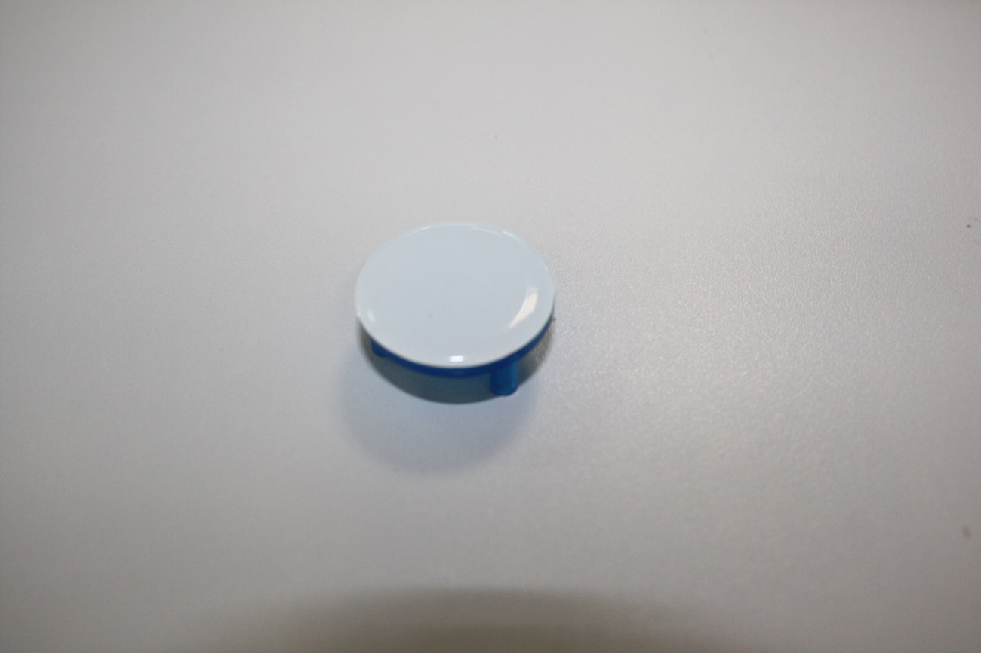
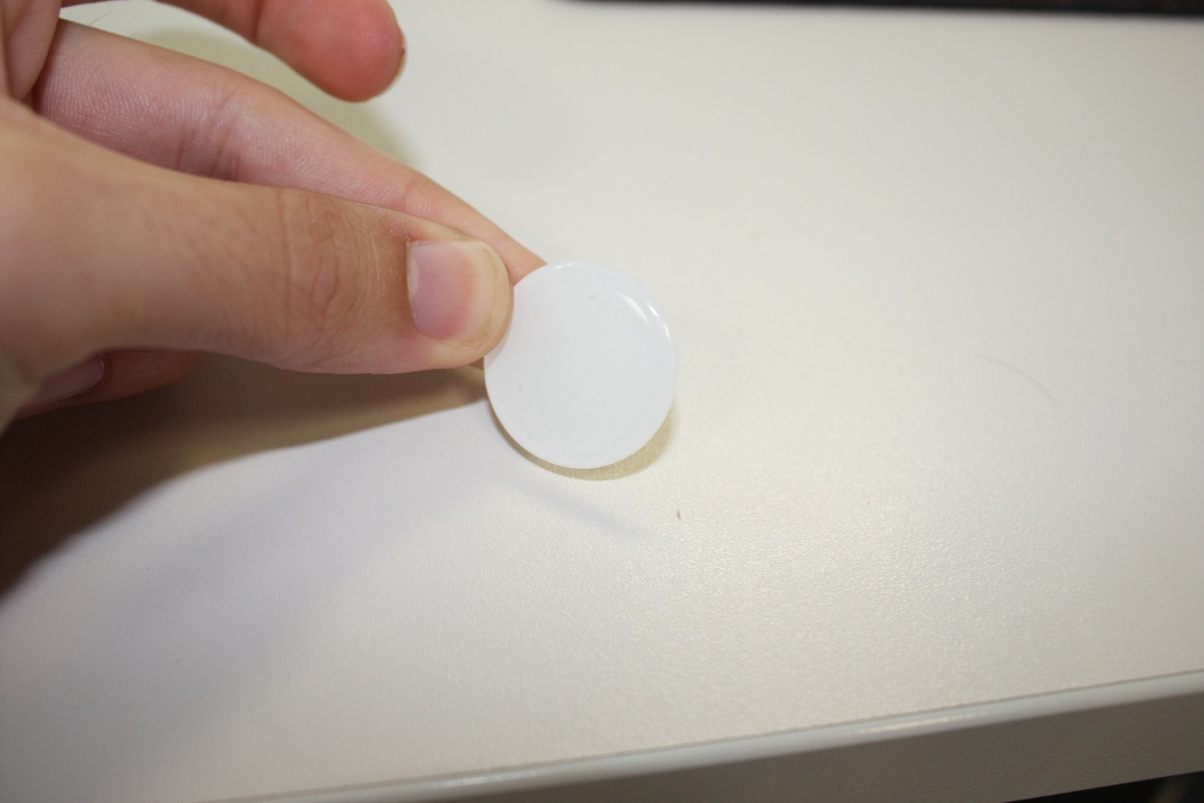

We need a sticker as the picture but with the form and color of our design.

APPUSBCAR MOLD FEATURES
APUSBCARW | Material | Colour | Finishing
1 Top | ABS | White | Polished
2 Bottom | ABS | White | Polished
3 Silk-screen in the sticker. | -------- | Pantone 877C (Silver) | -------
4 Sticker | Epoxy | Black | ------
5 Led | ---- | Green

APUSBCARB | Material | Colour |  | Finishing
1 Top | ABS | Black |  | Polished
2 Bottom | ABS | Black |  | Polished
3 Silk-screen | -------- | Pantone 877C (Silver) |  | -------
4 Sticker | Epoxy | White | ------
5 Led | ---- | Green | -------

APUSBCARP | Material | Colour |  | Finishing
1 Top | ABS | Purple Pantone 2597C |  | Polished
2 Bottom | ABS | Purple Pantone 2597C |  | Polished
3 Silk-screen | -------- | Pantone 877C (Silver) |  | -------
4 Sticker | Epoxy | White | ------
5 Led | ---- | Green |  | -------

The housing printing, we will send you in the ilustartor file.

APPUSBCAR31

Description | Approx Model | Picture
USB car charger 2 usb 5V3.1A White | APUSBCAR31W | 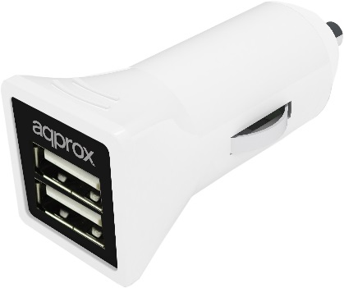
USB car charger 2 usb 5V3.1A Black | APUSBCAR31B | 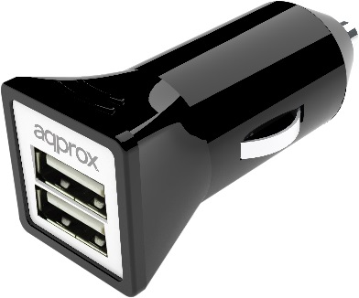
USB car charger 2 usb 5V3.1A Purple | APUSBCAR31P | 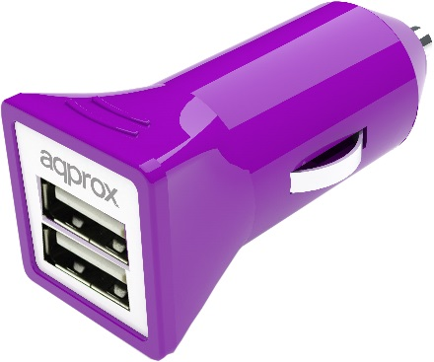

¡¡ATTECION!! THESE PICTURES ARE SAMPLE ONLY, IT ISN´T A COPY EXACTLY OF REALITY… THE COLOURS WILL BE THE INDICATED PANTONE AND DESIGN THE INDICATED IN THE STP. FILE

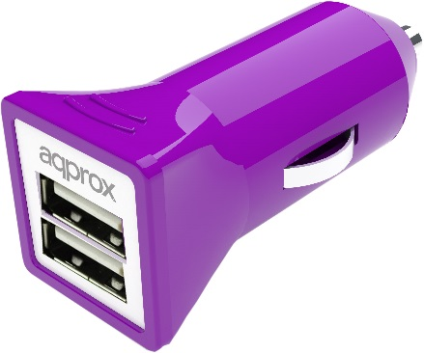
BOTTOM
TOP

STICKER

About the sticker, look the appusbcar*
APPUSBCAR31 MOLD FEATURES.
APUSBCAR31W | Material | Colour | Finishing
1 Top | ABS | White | Polished
2 Bottom | ABS | White | Polished
3 Silk-screen in the sticker. | -------- | Pantone 877C (Silver) | -------
4 Sticker | Epoxy | Black | ------

APUSBCAR31B | Material | Colour |  | Finishing
1 Top | ABS | Black |  | Polished
2 Bottom | ABS | Black |  | Polished
3 Silk-screen | -------- | Pantone 877C (Silver) |  | -------
4 Sticker | Epoxy | White | ------

APUSBCAR31P | Material | Colour |  | Finishing
1 Top | ABS | Purple Pantone 2597C |  | Polished
2 Bottom | ABS | Purple Pantone 2597C |  | Polished
3 Silk-screen | -------- | Pantone 877C (Silver) |  | -------
4 Sticker | Epoxy | White | ------

The housing printing, we will send you in the ilustartor file.

Approx Housing Requirements sheets
AppUSBWALL APPROX
Description | Approx Model | Picture
USB Travel Wall charger 5V1A 1USB Black  USB Travel Wall charger5V2.1A 2USB Black | AppUSBWALL1B  APPUSBWALL21B | 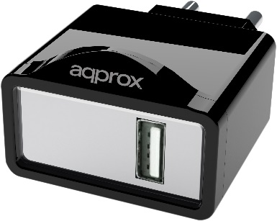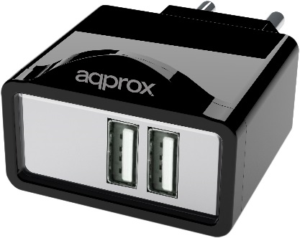
USB Travel Wall charger 5V1A 1USB White  USB Travel Wall charger5V2.1A 2USB White | AppUSBWALL1W  APPUSBWALL21W | 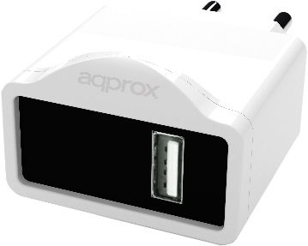  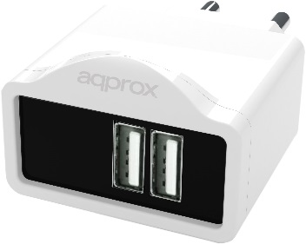
USB Travel Wall charger 5V1A 1USB  Purple  USB Travel Wall charger5V2.1A 2USB Purple | AppUSBWALL1P  APPUSBWALL21P | 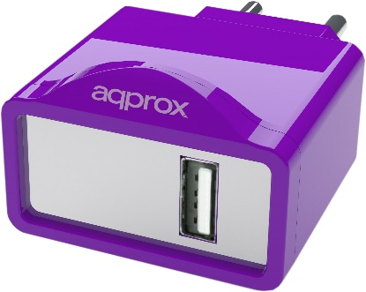  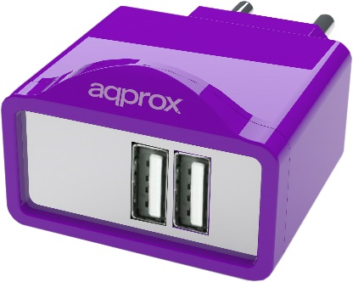
¡¡ATTECION!! THESE PICTURES ARE SAMPLE ONLY, IT ISN´T A COPY EXACTLY OF REALITY… THE COLOURS WILL BE THE INDICATED PANTONE AND DESIGN THE INDICATED IN THE STP. FILE.

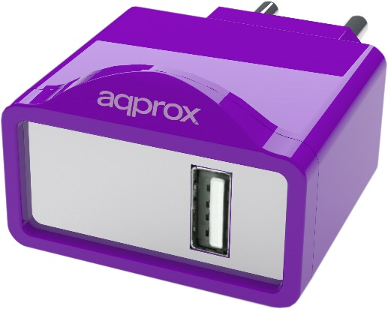
The parts of this product isn´t defined yet. But it will have two parts and the sticker.

APPUSBWALL MOLD FEATURES.
AppUSBWALL1W  APPUSBWALL21W | Material | Colour | Finishing
1 Top | ABS | White | Polished
2 Bottom | ABS | White | Polished
3 Silk-screen in the sticker. | -------- | Pantone 877C (Silver) | -------
4 Sticker | Epoxy | Black | ------

AppUSBWALL1B  APPUSBWALL21B | Material | Colour |  | Finishing
1 Top | ABS | Black |  | Polished
2 Bottom | ABS | Black |  | Polished
3 Silk-screen | -------- | Pantone 877C (Silver) |  | -------
4 Sticker | Epoxy | White | ------

AppUSBWALL1P  APPUSBWALL21P | Material | Colour |  | Finishing
1 Top | ABS | Purple Pantone 2597C |  | Polished
2 Bottom | ABS | Purple Pantone 2597C |  | Polished
3 Silk-screen | -------- | Pantone 877C (Silver) |  | -------
4 Sticker | Epoxy | White | ------

About the sticker, look the appusbcar*

The housing printing, we will send you in the ilustartor file.

The added fuction for this product is support of the mobile:
The pieces should be assembled very well for this function to be possible.

As pictures:

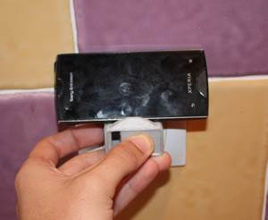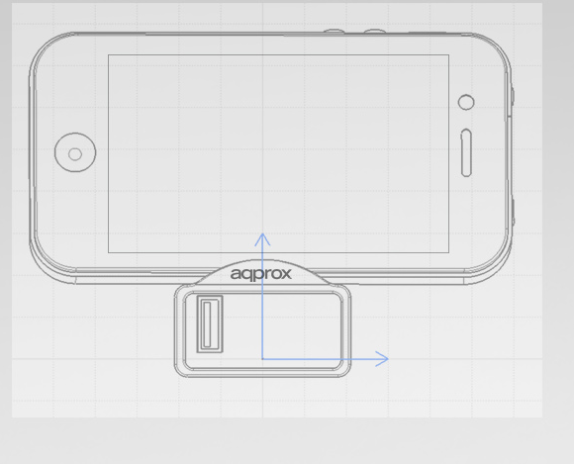

The frontal arc is for to stop to device for to prevent fall.
Too, we need that this product to have two slip rubbers in the surface, as this picture,
for the same goal.
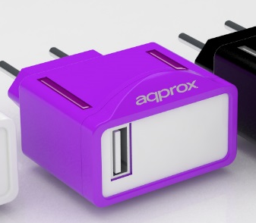
Slip rubbers
These slips should be the same color that top and bottom for in each case.

